# Communicate

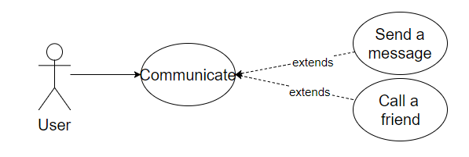

## Characteristic Information

|  |  |
| --- | --- |
| Superior business process: | Process-ID: refers to section 2.5.1 (business processes)> |
| Goal: | Is to communicate with friends in term of sending him messages or talking to him |
| Precondition: | Needs to have a friend in his friendlist  If you want to talk then your friend needs to accept the call |
| Postcondition: | The text cronic is saved  The user communicated with his friend |
| Involved User: | The User talks/writs with his friend  The friend talks/writs back |
| Triggering Event: | When the user sends a massage  When a user calls a friend |

## GUI to call the use case

| Input field | Valid inputs |
| --- | --- |
| MessageTextBox | As in communicate with friends |

## GUIs for the standard use

| Step | User | Activity |
| --- | --- | --- |
| 1 | User | Start program |
| 2 | User | Select friend |
| 3 | User | Send a message or call him |

## Scenarios for non-standard uses (bad cases or work around cases)

## GUIs for the non-standard uses

## Workflow

## Open Points